Image Lists
Talent Pools List + Abilities

Misc Abilities
 | Strike
 | Move
 | Block
 | Shoot

Brawler
Image | Ability/Passive Name
 | Whirlwind
 | Devastating Blow
 | Tenacious
 | Smash
 | Charge
 | Kick to the Balls
 | Masochist
 | Recklessness
 | Blade Flurry
 | Last Stand

Duelist
Image | Ability / Passive Name
 | Dash
 | Tendon Slash
 | Slippery
 | Riposte
 | Shield Shatter
 | Evasion
 | Disarm
 | Perfect Reflexes
 | Decapitate
 | Second Wind

Assassination
Image | Passive/Ability Name
 | Vanish
 | Cheap Shot
 | Shank
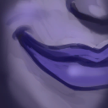 | Opportunist
 | Shadow Step
 | Ambush
 | Patient Stalker
 | Stalk
 | Sharpen Blade
 | Preparation
 | Slice And Dice
 | Stealth

Guardian
 | Provoke
 | Guard
 | Cautious
 | Sword And Board
 | Get Down!
 | Shield Slam
 | Testudo
 | Guardian Aura
 | Reactive Armour
 | Challenging Shout
 | Unwavering

Pyromania
 | Fiery Ball
 | Fiery Aura
 | Fire Nova
 | Phoenix Dive
 | Meteor
 | Immolation
 | Blaze
 | Combustion
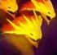 | Dragon Breath
 | Demon

Cyromancy
 | Frost Nova
 | Chilling Blow
 | Icy Focus
 | Shatter
 | Blizzard
 | Frost Armour
 | Frost Bolt
 | Glacial Burst
 | Creeping Frost
 | Thaw
 | Frozen Heart

Ranger
 | Snipe
 | Haste
 | Impaling Bolt
 | Predator
 | Steady Hands
 | Head Shot
 | Forest Medicine
 | Tree Leap
 | Concentration
 | Rapid Fire
 | Overwatch
 | Hawk Eye 2

Manipulation
 | Telekinesis
 | Flux
 | Dimensional Blast
 | Mirage
 | Phase Shift
 | Burst Of Knowledge
 | Blink
 | Phasing
 | Infuse
 | Ethereal Being
 | Time Warp
 | Dimensional Hex

Divinity
 | Holy Fire
 | Inspire
 | Consecrate
 | Encouraging Aura
 | Invigorate
 | Bless
 | Radiance
 | Purity
 | Blinding Light
 | Transcendence
 | Sacred Aura
 | Judgement

Shadowcraft
 | Shadow Blast
 | Shroud
 | Hex
 | Shadow Aura
 | Chaos Bolt
 | Nightmare
 | Rain Of Chaos
 | Shadow Wreath
 | Shadow Form
 | Unbridled Chaos

Corruption
 | Poisonous
 | Blight
 | Blood Offering
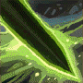 | Toxic Slash
 | Venomous
 | Noxious Fumes
 | Toxic Eruption
 | Chemical Reaction
 | Drain
 | Toxicity
 | Toxic Aura

Naturalism
 | Spirit Surge
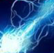 | Lightning Bolt
 | Thunder Strike
 | Storm Aura
 | Spirit Vision
 | Primal Rage
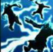 | Chain Lightning
 | Thunder Storm
 | Pressurise
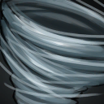 | Concealing Clouds
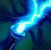 | Super Conductor
 | Storm Lord

Passive Traits and Icon Images

Image | Name | Description
 | Strength | Each point increases the base damage of melee attacks by 1
 | Wisdom | Each point increases all fire, shadow, frost, poison and air damage by 1.
 | Mobility | Each point increases the distance in tiles a character can travel with movement abilities by 1
 | Initiative | Each point adds +1 to your activation order roll on each turn.
 | Stamina | Each point increase the amount of energy gained on activation start by 1
 | Dexterity | Each point increase the block gained by abilities and passive effects by 1
 | Dodge | Each point increase your chance to completely avoid damage from ranged attacks by 1%
 | Parry
 | Aura Size
 | Critical Strike
 | Melee Critical
 | Ranged Critical
 | Fiery Imbuement
 | Poison Imbuement
 | Frost Imbuement
 | Shadow Imbuement
 | Air Imbuement
 | Immobilized
 | Blind
 | Disarmed
 | Silenced
 | Stunned
 | Terrified
 | Weakened
 | Vulnerable
 | Chilled
 | Shocked
 | Sleep
 | Unleashed | This character cannot be teleported or Imobilized
 | Unstoppable | Immune to Stunned and Sleep
 | Unwavering | This character's Block does not expire on activation end
 | Unfallible | This character is immune to Blind, Disarm and Silence
 | Incorruptable | This character is immune to Weakened and Vulnerable.
 | Camoflage | This character cannot be targetted by enemy abilities from further then 1 tile away. Using an attack ability, or taking damage will remove this.
 | Stealth | This character is permanently Camoflaged
 | Patient Stalker | While camoflaged, this character has +10 Stamina and +1 mobility
 | Predator | Your attacks have +20 Critical Chance while you have Camoflage
 | Flux | The character's first 'Move' ability each turn costs 0 Energy
 | Lifesteal | This character's melee attacks that reduce health heal for that amount
 | Undead | Immune to Poisoned
 | True Sight | This character ignores Camoflage
 | Perfect Aim | Your Ranged Attacks cannot be dodged.
 | Frozen Heart | +20 Frost Resistance. Increase all Frost Damage dealt by 20%
 | Demon | +20 Fire Resistance. Increase all Fire Damage dealt by 20%
 | Toxicity | +20 Poison Resistance. Increase all Poison Damage dealt by 20%
 | Shadow Form | +20 Shadow Resistance. Increase all Shadow Damage dealt by 20%
 | Storm Lord | +20 Air Resistance. Increase all Air Damage dealt by 20%
 | Nimble | +10 Dodge and Parry Chance
 | Masochist | While this character has 50% or less health, it has +20% Critical Chance
 | Slippery | Immune to free strikes
 | Last Stand | The first time this character would take lethal damage each combat, it instead has its health reduced to one, then gains +5 strength.
 | Riposte | Whenever this character parries an attack, it melee attacks its attacker for 100% weapon damage.
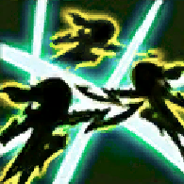 | Perfect Reflexes | +20 Dodge and Parry Chance
 | Shatter | Your attacks against targets with 'Chilled' have +20 Critical Chance.
 | Ethereal Being | You ignore all obstacles when determining line of sight. You can walk through trees and over water
 | Phasing | The first time this character is attacked each turn cycle, it teleports to a random tile within 2 of its current location
 | Burning | This character takes X Fire damage on activation end.
 | Poisoned | This character takes X Poison damage on activation end.
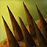 | Thorns | Whenever this character is hit with a melee attack, it deals X Physical damage to its attacker.
 | Cautious | On activation end, if this character has no block, it gains X Block
 | Volatile | This character explodes on death, dealing X Physical damage to all adjacent characters
 | Growing | On activation end, this character gains X Strength
 | Enrage | Whenever this character loses health, it gains X Strength
 | Regeneration | On activation end, this character recovers X health
 | Venomous | Whenever this character applies Poisoned, it applies X more.
 | Poisonous | Whenever this character reduces health with an attack, it applies X 'Poisoned'
 | Immolation | Whenever this character reduces health with an attack, it applies X 'Burning'
 | Tenacious | Whenever you lose health, gain X Block
 | Fading | On Activation end, this character loses X health
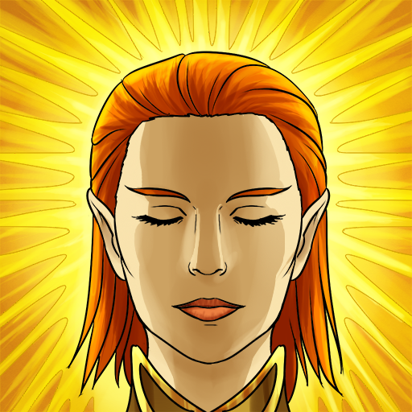 | Radiance | Increase the range of your aura effects by X
 | Hawk Eye | Increase the range of Ranged Attack abilities by X
 | Knowledgeable | Your skills cost X less Energy
 | Pragmatic | Your Ranged Attacks cost X less Energy
 | Savage | Your Melee Attacks costs X less Energy
 | Godlike | Your Abilities cost X less Energy
 | Powerful | You can have X additional Power abilities active at a time
 | Opportunist | This character's melee attacks deal X% more damage when attacking a target's back
 | Encouraging Aura | On activation end, this character grants X Energy to allies within its Aura
 | Fiery Aura | On activation end, this character deals X Fire damage to enemies within its Aura
 | Toxic Aura | On activation end, this character applies X Poisoned to enemies within its Aura
 | Storm Aura | On activation end, this character deals X Air damage to a random enemy within its Aura twice.
 | Hateful Aura | On activation end, this character grants X Strength to allies within its Aura
 | Soul Drain Aura | On activation end, this character steals X Strength from enemies within its Aura
 | Guardian Aura | On activation end, this character gives X Block to allies within its Aura.
 | Sanctity Aura | On activation end, remove Stun, Crippled, Blind, Disarmed, Confused, and Terrified from all allies withn (aura size)
 | Shadow Aura | On activation end, apply 1 weakened to all enemies within (aura size)

